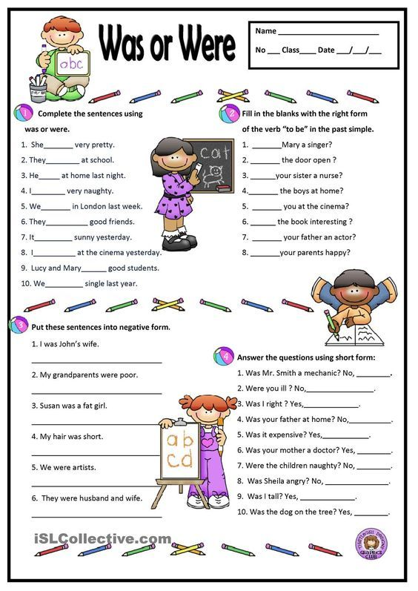

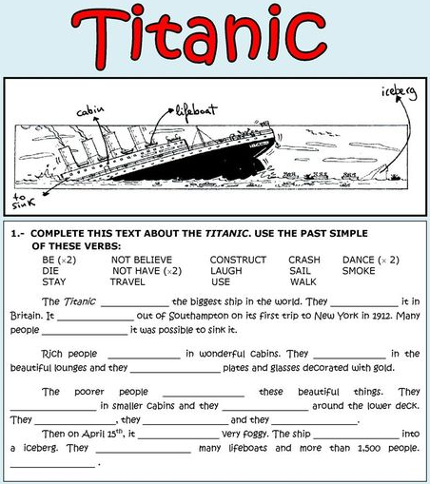

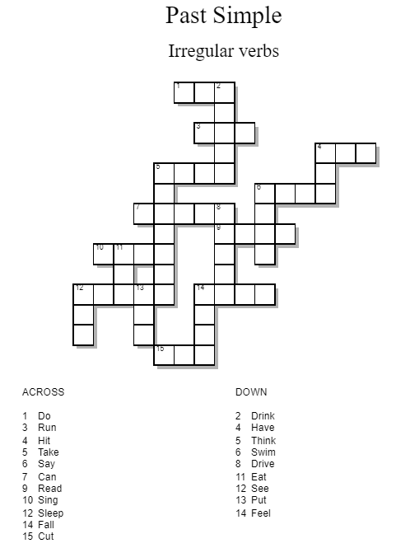

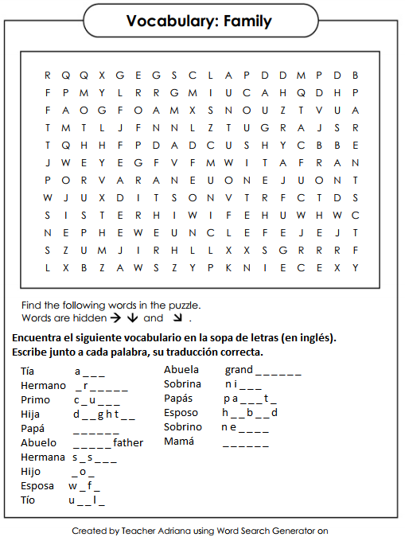

**Present Simple and Present Continuous**

**Complete the following chart with the affirmative, negative and/or interrogative form of the sentences in Present Continuous.**

|  |  |  |
| --- | --- | --- |
| + I am driving a car  -  ? | +  -  ? Is she planning a party? | +  - You are not listening to me.  ? |
| +  - She is not taking her medicine.  ? | +  -  ? Are you joking? | + It is raining.  -  ? |
| +  - It is not snowing  ? | + We are dancing tango.  -  ? | +  -  ? Is she making pizza? |
| +  -  ? Is he dancing with that girl? | + They are looking at us!  -  ? | + She is drinking coffee.  -  ? |
| +  - We are not making any noise.  ? | +  - I am not understanding you.  ? | +  -  ? Is he sleeping at night? |
| +  - She isn’t watching cartoons  ? | +  -  ? Are you talking to me? | + They are arriving at the party  -  ? |
| +  -  ? Is he washing dishes? | + She is playing with your heart  -  ? | +  - We are not taking this course.  ? |

**Complete the next chart by transforming the sentences**

|  |  |
| --- | --- |
| Present Simple | Present Progressive |
| He cleans his house |  |
| They look happy |  |
|  | She is telling a lie |
| It bites hard |  |
|  | They are singing a song |
|  | He is looking after you |
| She loves pizza |  |
|  | We are kissing a cat |
|  | Daniel is looking for you |
| I play the piano |  |

**Present Simple and Past Simple**

**Completa la siguiente tabla, escribiendo la forma afirmativa, negativa e interrogativa de las oraciones escritas en Presente Simple. Después, tomando en cuenta que todos los verbos utilizados son VERBOS REGULARES, transfórmalas a Pasado Simple.**

|  |  |  |
| --- | --- | --- |
| PRESENT Simple |  |  |
| + I walk to school every morning  -  ? | +  -  ? |
| +  - She doesn’t play the Banjo  ? | +  -  ? |
| +  -  ? Do we live in London? | +  -  ? |
| + She dances to jazz music  -  ? | +  -  ? |
| +  - We do not listen to pop music  ? | +  -  ? |
| +  - They don’t like potato chips  ? | +  -  ? |
| +  -  ? Do I wash the dishes? | +  -  ? |

**Completa la siguiente tabla transformando las oraciones según se te pida**

|  |  |
| --- | --- |
| Present Simple | Past Simple |
| He cleans his house |  |
| They look happy |  |
|  | She is telling a lie |
| It bites hard |  |
|  | They are singing a song |
|  | He is looking after you |
| She loves pizza |  |
|  | We are killing a cat |
|  | Daniel is cheating on you |
| I play the piano |  |